TEAM ID : PNT2022TMID28791 NAME : A.Jyothicharan

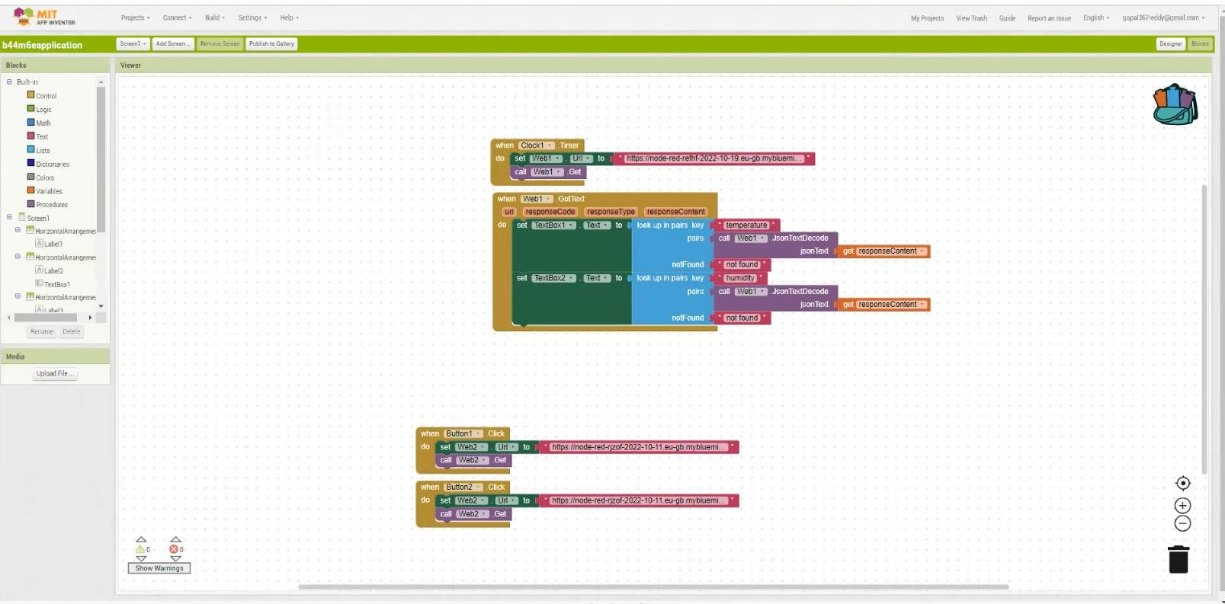Testing the application using the required inputs:

